REACT NOTES

What is React?
It's a javascript library to create and compose components.

What is React App?
It’s a composition of components.

- React doesn't use html directly, instead it uses a javascript tree of objects. So we are writing javascript and not html in the UI.
- With React we display a reflection of the state of the app and only render the object that is needed.
- JSX it’s the way to write friendly React code.
- JSX can use a tool like Babel (Javascript compiler) to transform the friendly code with html aspect to the React code.
- The workflow it’s: JSX => React code => React Dom (where the browser renders only the needed object).

Tree reconciliation?
It’s the capacity to render only the component we need.

Component?
Each component has a name, has props and state and it has tree characteristics.
- It can accept inputs for other components by using “props”. In JSX the props are written as html attributes.
- Can export and import from others components.

import and export syntaxis?
A module can export members with the keyword “export”. All members without this keyword can not be imported for other modules.
To import a member from other module:
import {component} from “./big”
Where component is the element name from the module named big.
If use export default keyword no needed to use curly brace
import comp from “./big”

What is Node?
Node.js is an open-source and cross-platform JavaScript runtime environment. It is a popular tool for almost any kind of project!

What is npm?
Node Package Manager, which is an application and repository for developing and sharing JavaScript code.

Commands in Console
To install latest npm version:
npm install npm@latest -g

To create initial folder app with dependencies:
First: select the folder
Second: npx create-react-ap nameapp

npm start (starts the development server in development mode allowing debug).
npm run build ( bundles the app into static files for production).
npm test ( starts test runner).
npm run eject ( removes dependencies).

public folder vs src folder
Everything in the public folder will not be processed by webpack instead in the src folder that all his content will be processed.

function component vs class component
function if we need only to render simple JSX
class component support states and life cycle and you can put in members.

webpack
Webpack is a popular module bundling system built on top of Node.js. It can handle not only combination and minification of JavaScript and CSS files, but also other assets such as image files (spriting) through the use of plugins. Webpack is the recommended bundling solution and should be preferred over Cassette or ASP.NET Bundling.

props
props = like arguments that can pass in to other components, and represent an object.
props cannot be changed; they are read-only.
props can be accessed in class components using this.props.

Fetching data
We can use the fetch api to read files.
Fetch its only available in new browsers

state
In order to allow components to manage and change their data, React provides a feature called state.
State is an object that is added as a property in class components.
The state object can contain multiple key:value pairs, separated by commas and they can be accessed with this.state
State should not be modified directly. Instead, React provides a setState() method that can be used to modify state.
When state changes using the setState method, React gets informed and immediately re-renders the component with the updated state.
Components that have state are called stateful, while components that do not use state are called stateless.

state it’s private data from the component.
the state object itself it’s private.
state is always used in render
setState is the way to put what we need to render.

props vs state
We use props to pass data to components.
Components use state to manage their data.
Props are read-only and cannot be modified.
State can be modified by its component using the setState() method.
The setState() method results in re-rendering the component affected.

Life cycle methods
Methods called automatic by React on a class component when the life cycle state changed on de component.

Mounting: Editing the components to create the React tree. (DOM)

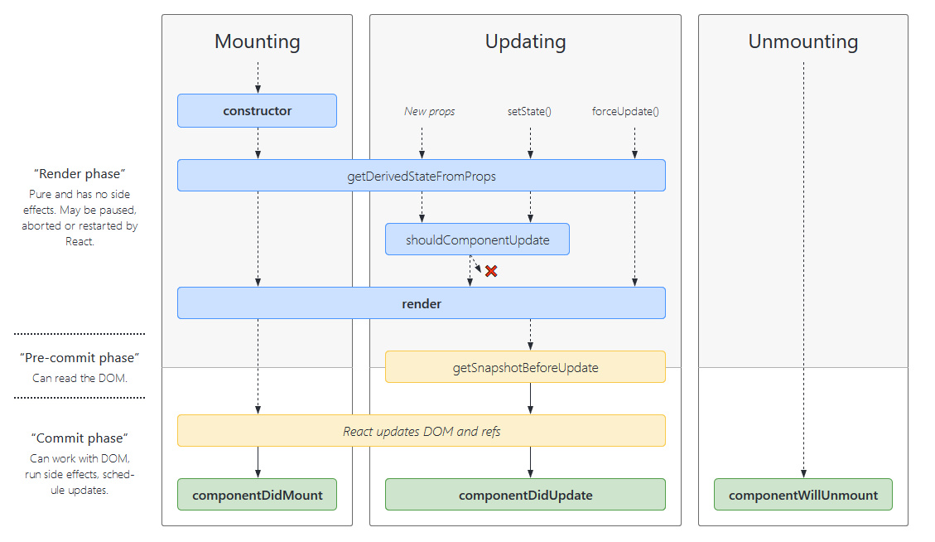

Error boundaries

ComponentDidCatch() for error handling

Hooks

React router

Context

Flux vs Redux
Flux is an architectural pattern for complex apps that generate a new conception of state and UI updates and redux is an implementation

Unit testing with Jest

Best Practices
Separate State and UI

